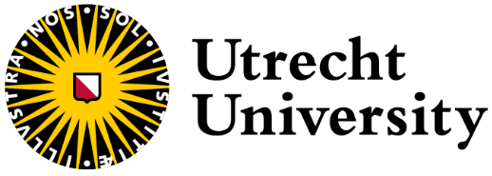
Immuno-oncology Summer School

A Biomedical Research lab experience

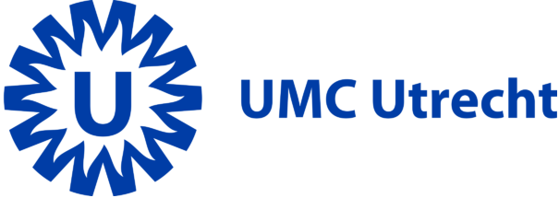

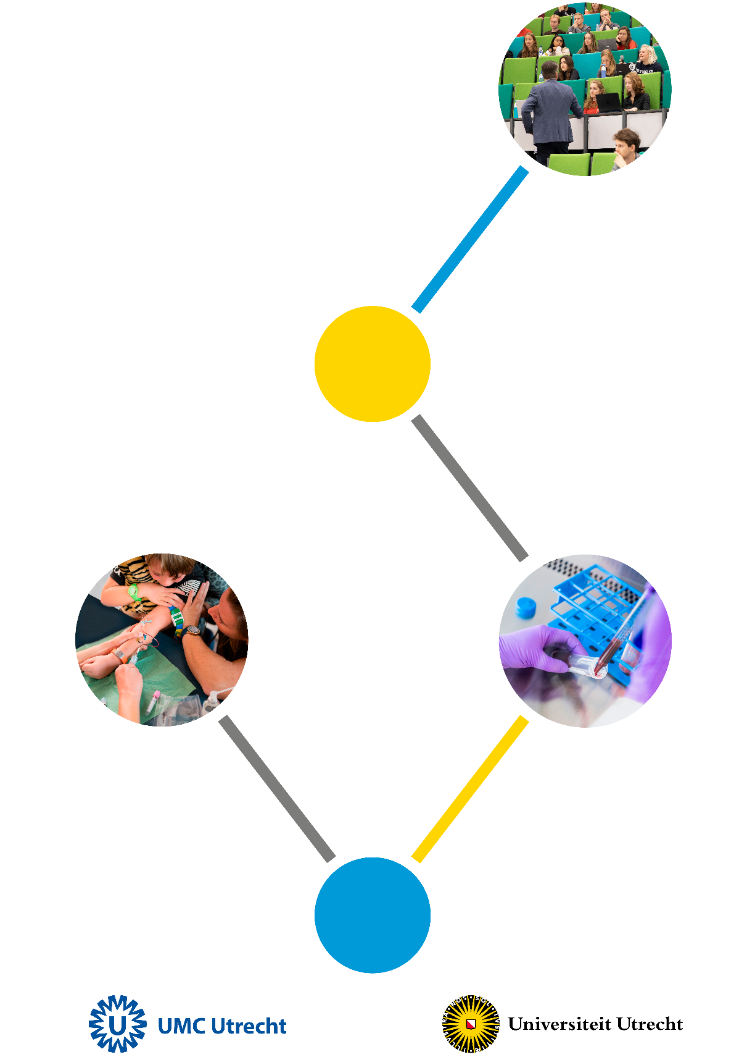

Towards immunotherapy for Medulloblastoma

© 2025
The copyrights of this syllabus are held by the University Medical Center Utrecht. No part of this document may be reproduced and / or made public by means of print, photocopy, microfilm or in any other way, nor stored in a data retrieval system, without the prior written permission of the UMC Utrecht.
Coordinator:

Prof. Dr. N. Bovenschen
UMCU Department of Pathology
Heidelberglaan 100
3584 CX Utrecht
Tel: 088-7553889
Secretary: 088-7556565 (Ms E. Post)
E-mail: n.bovenschen@umcutrecht.nl
E-mail (secr.): e.t.m.post@umcutrecht.nl

Staff:

Prof. Dr. N. Bovenschen Pathology-UMCU n.bovenschen@umcutrecht.nl

Dr. T. ten Broeke Pathology-UMCU A.G.tenBroeke-2@umcutrecht.nl

Dr. S. Crnko Pathology-UMCU s.crnko@umcutrecht.nl

Dr. T. Koorman Pathology-UMCU t.koorman@umcutrecht.nl

E. Pijnappel Pathology-UMCU E.W.Pijnappel-2@umcutrecht.nl

J. Meeldijk Pathology-UMCU / CTI J.Meeldijk@umcutrecht.nl

H. Rebel Pathology-UMCU H.G.Rebel-2@umcutrecht.nl

S. van Dijk Pathology-UMCU S.M.vanDijk@umcutrecht.nl

M. Quist Pathology-UMCU K.M.Quist@umcutrecht.nl

D. Maassen Pathology-UMCU D.S.C.Maassen-6@umcutrecht.nl

M. Schakelaar Pathology-UMCU M.Y.Schakelaar-5@umcutrecht.nl

M. Monnikhof Pathology-UMCU M.Monnikhof@umcutrecht.nl

Preface

Welcome to the Biomedicine Student Research Hub for the Immuno-oncology Summer School, taking place in the newly equipped laboratory positioned in the heart of the University Medical Centre Utrecht. During the 2-week period you will be performing an authentic and real-world actual research under supervision of professionally trained teacher-researchers. You will experience a “crash-course” in the scientific world: from thinking about the topic, investigating the current literature, and writing a short project proposal, to conducting the experimental part of the research, and finally presenting and discussing your data. Sharing your findings and knowledge is always an important part of the research, therefore it is useful to get acquainted with it and practice it at the very start of your scientific careers.
The topic of the Summer school will revolve around medulloblastoma – one of the most common brain tumours in children. Currently, there are three therapeutical options for medulloblastoma: surgery, radiation and chemotherapy. Although survival rates vary from 65-85%, the quality of life of the patients is severely affected. Thus, there is a need for improved or new therapies. In recent years, immunotherapies have proven to be successful strategies in the treatment of cancer. During the course, you will investigate options for using immunotherapy as a future treatment for this disease by incorporating your own ideas and choosing your own research paths. For more information about our Summer School, check out this video:
https://www.youtube.com/watch?v=_QrUizVL-uM

We wish to welcome you to our laboratory where, with a support of many supervisors, you can get a glimpse of the real scientific world. Happy researching!
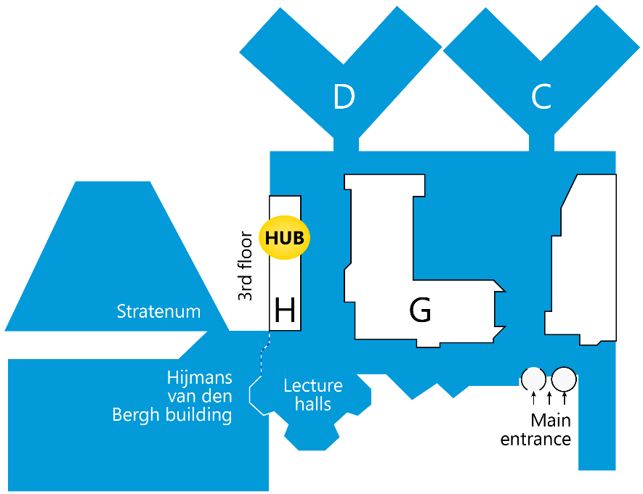
Location: Biomedicine Student Research Hub (H03.201), UMC Utrecht (Heidelberglaan 100, 3584 CX Utrecht)

With kind regards,
Niels Bovenschen, Toine ten Broeke, Sandra Crnko, Thijs Koorman, Emma Pijnappel, Heggert Rebel, Suzanne van Dijk, Matthias Quist, Daniëlle Maassen Michael Schakelaar, Matthijs Monnikhof, and Jan Meeldijk

Literature

The following articles and videos will give you an insight into the topic and techniques you will be using during the Summer school.

- Medulloblastoma
Paul A. Northcott, Giles W. Robinson, Christian P. Kratz, Donald J. Mabbott, Scott L. Pomeroy,
Steven C. Clifford, Stefan Rutkowski, David W. Ellison, David Malkin, Michael D. Taylor, Amar
Gajjar & Stefan M. Pfister
Nature Reviews Disease Primers volume 5, Article number: 11 (2019)
https://www.nature.com/articles/s41572-019-0063-6

- The blockade of immune checkpoints in cancer immunotherapy
Drew M. Pardoll
Nature Reviews Cancer volume 12, pages 252–264 (2012)
https://www.nature.com/articles/nrc3239

- Immunotherapy in medulloblastoma: Current State of Research, Challenges, and Future Perspectives
Marije J. Voskamp, Shuang Li, Kim R. van Daalen, Sandra Crnko, Toine Ten Broeke, Niels Bovenschen
Cancers 13(21):5387 (2021)
https://pubmed.ncbi.nlm.nih.gov/34771550/

- Biomedicine Student Research Hub
https://www.youtube.com/watch?v=PmBeLLvpXHw
https://www.bachelorresearchhub.com/

- Western blot tutorial
https://www.youtube.com/watch?v=CEEekahiqMo

- Cell culture tutorial
https://www.thermofisher.com/nl/en/home/references/gibco-cell-culture-basics/introduction-to-cell-culture.html

- Flow cytometry tutorial
https://www.youtube.com/watch?v=sfWWxFBltpQ

Schedule

Week July 7th-July 11th:

Monday:

- Gathering at the main entrance 08:55-09:00h Everyone
of UMC Utrecht
- Introduction to the Summer school 09:00-09:15h N. Bovenschen
- Introduction of the topic 09:15-10:00h N. Bovenschen
- Hypothesis formulation, planning and 10:15-17:00h Students
preparations

Tuesday:

- Lab journal 09:00-09:30h T. ten Broeke
- Discussion of the hypothesis and 09:30-10:00h Everyone
planned lab work
- Lab work* 10:15-17:00h Students

Wednesday:

- Lab work 09:00-17:00h Students

Thursday:

- Lab work 09:00-17:00h Students

Friday:

- Recap results (short ppt) 09:00-09:45h Everyone
+ Planning for the next week
- Lunch walk in the Botanical garden UU 12:00-13:00 Everyone
- Lab work 10:00-17:00h Students

*Lab work includes: molecular biology, cell culture, Western blot, Flow cytometry, etc.

Week July 14th-18th:

Monday:

- Lab work* 09:00-17:00h Students

Tuesday:

- Lab work 09:00-17:00h Students

Wednesday:

- Lab work 09:00-17:00h Students

Thursday:

- Lab work 09:00-17:00h Students

Friday:
- Presentation preparation 09:00-15:00h Students
- Final presentation (30min+discussion) 15:00-15:45h Students
- Closing remarks 15:45-17:00h N. Bovenschen

*Lab work includes: molecular biology, cell culture, Western blot, Flow cytometry, etc. (see list of techniques on the last page of syllabus)

Knowledge of techniques per teacher

 | Toine | Sandra | Thijs | Emma | Heggert | Suzanne | Matthias | Daniëlle | Jan | Matthijs | Michael
Cell culture | +++ | +++ | +++ | +++ | +++ | ++ | +++ | +++ | +++ | +++ | +++
Western Blot | +++ | ++ | +++ | ++ | +++ | - | +++ | +/- | +++ | ++ | +++
RNA isolation, cDNA synthesis, and qPCR | + | +++ | +++ | ++ | ++ | +/- | +++ | +++ | +++ | + | +++
Flow cytometry | +++ | +/- | +++ | +/- | ++ | - | +++ | +++ | ++ | +++ | +++
Cloning | ++ | - | ++ | - | ++ | - | ++ | - | +++ | +/- | ++
Immuno-fluorescence | +++ | +/- | +++ | +/- | +++ | +++ | ++ | + | + | - | +/-
Immuno-histochemistry | + | ++ | ++ | +++ | +++ | +++ | + | - | + | - | -
Transfection | ++ | ++ | +++ | ++ | + | - | - | + | +++ | ++ | +
PBMC + NK cell isolation | +++ | +/- | +++ | - | +++ | - | +++ | +++ | + | +++ | +++
XCElligence | ++ | + | - | - | ++ | - | - | - | ? | - | -
Confocal microscopy | +++ | ++ | +++ | + | +++ | +++ | +/- | + | +++ | + | +

- = Has no knowledge of this technique
+/- = Has almost no knowledge of this technique
+ = Has a little knowledge of this technique
++ = Has a lot of knowledge of this technique, but cannot answer all questions concerning the technique
+++ = Has all the knowledge of this technique and can answer difficult questions concerning the technique

Techniques and facilities available in or via the Hub

- Flowcytometry
  - Cytoflex (HUB)
  - BDCantoII (Flow facility)
- Immunohistochemistry
- qPCR
- Western Blot
- SEM (in collaboration with Cell Microscopy Center, Tineke Veenendaal)
- Confocal imaging
- Immunofluorescence
- Cell culture
- Transfection
- Cloning
- Killing assays
- PBMC and Primary NK cell isolation from healthy donor blood
- Making of fusion proteins
- Electroporation
- XCELLigence

Chemicals can be found according to the SOPs. If not present, consult the HUB team for more information.

